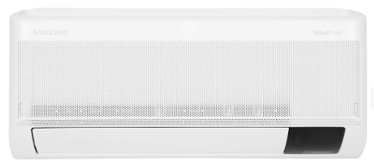Finish on23:00 | December 31In **Ho Chi Minh**

**8.990.000₫**~~10.090.000₫~~ (-10%)

**Promotion worth 1,300,000 VND**

Prices and promotions may end earlier than expected

first

Choose 1 of the promotions:

- No copper pipes and supplies will be given away.  
- Delivery only, no installation.

**Technical specifications of Samsung Inverter 1 HP AR10CYHAAWKNSV air conditioner**

* Machine Type:

1 way (cooling only) With Inverter

* Cooling capacity:

1 HP - 9,000 BTU

* Effective cooling range:

Under 15m² (from 30 to 45m³)

* Dust filter, antibacterial, deodorant:

Copper Anti-bacteria Filter

* Power saving technology:

Digital Inverter BoostEco

* Rapid cooling:

Fast Cooling

* Utilities:

Good Sleep mode Wind-Free mode for comfortable cold air Dehumidification function Auto Clean function Self-cleaning function Turn on and off timer Temperature display screen on the indoor unit Automatically restarts when power is available

* Power consumption:

0.84 kW/h 5 stars (Energy efficiency 4.56)

* Cooler:

Length 68.2 cm - Height 29.9 cm - Thickness 22.2 cm - Weight 8 kg

* Outdoor:

Length 72.1 cm - Height 47.5 cm - Thickness 29.4 cm - Weight 18.7 kg

Introducing the company 

- A brand from Korea, founded in 1938.  
- Samsung is a multi-industry corporation, with a high level of brand recognition on a global scale.  
- Samsung's products range from mobile devices, home appliances, electronics,...  
- With the strength of being the brand of a global corporation, the quality of products always reaches the highest level of perfection. , good warranty should be trusted by customers around the world.

[***Samsung Inverter 1 HP AR10CYHAAWKNSV air conditioner***](https://www.dienmayxanh.com/may-lanh/samsung-inverter-1-hp-ar10cyhaawknsv#2-gia)***is a 1-way air conditioner (cooling only) that possesses Digital Inverter Boost technology combined with Eco mode to help save energy. Fast Cooling mode helps speed up cooling, users do not take much time to reach the desired temperature. Copper Anti-bacteria Filter brings fresh air, protecting the whole family.***

**Design overview**

**Cooler:**

- Samsung AR10CYHAAWKNSV air conditioner has a simple design, delicate rounded corners, elegant **white color scheme .**

- **The temperature display screen**  is convenient to observe when in use.

**Outdoor:**

- Square rectangular design, sturdy shell, resistant to the impact of the external environment.

- The outdoor unit has **copper gas pipes** with high durability and good corrosion resistance, combined with **aluminum heatsinks** of compact size, convenient for installation and transportation.

- Using [**Gas R32**](https://www.dienmayxanh.com/kinh-nghiem-hay/cac-loai-gas-tren-may-lanh-588213#r32) helps cool quickly, is environmentally friendly, and saves electricity.

[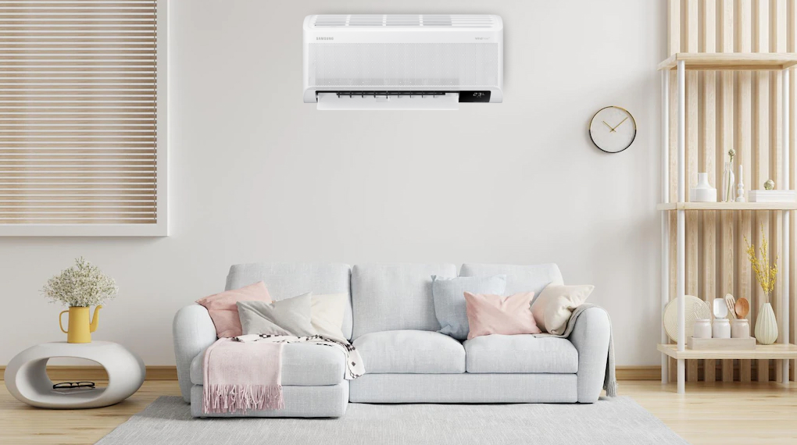](https://cdn.tgdd.vn/Products/Images/2002/304228/may-lanh-samsung-inverter-1-hp-ar10cyhaawknsv-240323-114509.png)

*\* Images are for illustration purposes only*

**Power saving technology**

- **ECO mode** uses less compressor capacity than normal mode, thereby reducing energy consumption, providing a pleasantly cool space while still effectively saving electricity.

[**- Digital Inverter Boost**](https://www.dienmayxanh.com/kinh-nghiem-hay/may-nen-inverter-8-cuc-tren-may-lanh-samsung-2016-817570) technology cools faster than conventional air conditioners thanks to the **8-pole Inverter compressor** , helping the machine operate stably and have a long life, **cooling capacity 43% faster** , while **saving up to 68% % electricity** .

**- The product has a 5-star** energy label , energy efficiency **4.56** .

**Air filtering ability**

**- Copper Anti-bacteria** Filter has the ability to effectively filter dust, providing a fresh space, ensuring health safety for the whole family. At the same time, you can easily remove the filter to clean it on [**the air conditioner .**](https://www.dienmayxanh.com/may-lanh)

**Refrigeration technology**

- Cooling capacity **of 1 HP - 9,000 BTU** , effective and optimal cooling for spaces with an area of **​​less than 15m² (from 30 to 45m³)** .

[**- Fast**](https://www.dienmayxanh.com/kinh-nghiem-hay/cac-che-do-lam-lanh-nhanh-thuong-gap-tren-may-lanh-837183#hmenuid2) Cooling technology helps cool the space up to **43%** quickly , users can enjoy a cool, comfortable feeling without spending much time waiting.

**Air blowing mechanism**

- [**Samsung air conditioner**](https://www.dienmayxanh.com/may-lanh-samsung) operates with a custom wind mode that automatically controls up, down, left and right to help cold air spread evenly throughout every corner of the room, bringing comfortable coolness in every location.

**Utilities**

- On days when the weather is rainy and humid, the humidity increases, the **dehumidifying function** helps the room become drier, preventing mold and bacteria from growing.

- [**Wind-Free mode cools quickly**](https://www.dienmayxanh.com/kinh-nghiem-hay/wind-freecong-nghe-lam-lanh-cua-tuong-lai-1068729) , no need to worry about cold wind blowing directly on the body but still maintains the user's desired temperature.

**- Auto Clean** self-cleaning function automatically dries the heat exchanger in 3 strict steps, helping to save time and costs on periodic cleaning. At the same time, the machine also removes moisture by blowing air for 10 - 30 minutes, preventing odors and mold growth.

- [**On/off timer**](https://www.dienmayxanh.com/kinh-nghiem-hay/cac-che-do-thuong-thay-tren-may-lanh-795107#hen-giohttps://www.dienmayxanh.com/kinh-nghiem-hay/cac-che-do-thuong-thay-tren-may-lanh-795107#hen-gio) helps proactively set on/off time according to usage needs.

- [**Automatically restarts when power is restored**](https://www.dienmayxanh.com/kinh-nghiem-hay/cac-che-do-thuong-thay-tren-may-lanh-795107#tu-khoi-dong) : the air conditioner can automatically restore previously installed features as soon as power is restored.

*In general, the Samsung Inverter 1 HP AR10CYHAAWKNSV air conditioner has a capacity of 1 HP - 9,000 BTU, suitable for spaces with an area of ​​less than 15m² (from 30 to 45m³). Capable of quick cooling with Fast Cooling mode, accompanied by the ability to filter air and dust with the Copper Anti-bacteria Filter to limit bacteria and mold, bringing fresh air to the whole family. .*